**SMART WASTE MANAGEMENT SYSTEM FOR METROPOLITAN CITIES**

**ASSIGNMENT-4**

**Submitted by**

**S.Rajalakshmi**

**ECE-IV**

**953119106024**

**Thamirabharani Engineering College**

**Team ID: PNT2022TMID50747**

**Write code and connections in wokwi for ultrasonic sensor.**

**Whenever distance is less than 100 cms send "alert" to ibm cloud and display in device recent events.**

**Code:**

#include <WiFi.h>

#include <PubSubClient.h>

WiFiClient wifiClient;

String data3;

#define ORG "4yi0vc"

#define DEVICE_TYPE "measurement_assignment"

#define DEVICE_ID "node_mcu"

#define TOKEN "123456789"

#define speed 0.034

#define led 14

char server[] = ORG ".messaging.internetofthings.ibmcloud.com";

char publishTopic[] = "iot-2/evt/Gayathri/fmt/json";

char topic[] = "iot-2/cmd/home/fmt/String";

char authMethod[] = "use-token-auth";

char token[] = TOKEN;

char clientId[] = "d:" ORG ":" DEVICE_TYPE ":" DEVICE_ID;

PubSubClient client(server, 1883, wifiClient);

void publishData();

const int trigpin=5;

const int echopin=18;

String command;

String data="";

long duration;

float dist;

void setup()

{

**Serial**.begin(115200);

  pinMode(led, OUTPUT);

  pinMode(trigpin, OUTPUT);

  pinMode(echopin, INPUT);

  wifiConnect();

  mqttConnect();

}

void loop() {

  bool isNearby = dist < 100;

  digitalWrite(led, isNearby);

  publishData();

  delay(500);

  if (!client.loop()) {

    mqttConnect();

  }

}

void wifiConnect() {

**Serial**.print("Connecting to "); **Serial**.print("Wifi");

  WiFi.begin("Wokwi-GUEST", "", 6);

  while (WiFi.status() != WL_CONNECTED) {

    delay(500);

**Serial**.print(".");

  }

**Serial**.print("WiFi connected, IP address: "); **Serial**.println(WiFi.localIP());

}

void mqttConnect() {

  if (!client.connected()) {

**Serial**.print("Reconnecting MQTT client to "); **Serial**.println(server);

    while (!client.connect(clientId, authMethod, token)) {

**Serial**.print(".");

      delay(500);

    }

    initManagedDevice();

**Serial**.println();

  }

}

void initManagedDevice() {

  if (client.subscribe(topic)) {

    // Serial.println(client.subscribe(topic));

**Serial**.println("IBM subscribe to cmd OK");

  } else {

**Serial**.println("subscribe to cmd FAILED");

  }

}

void publishData()

{

  digitalWrite(trigpin,LOW);

  digitalWrite(trigpin,HIGH);

  delayMicroseconds(10);

  digitalWrite(trigpin,LOW);

  duration=pulseIn(echopin,HIGH);

  dist=duration*speed/2;

  if(dist<100){

    String payload = "{\"Alert Distance\":";

    payload += dist;

    payload += "}";

**Serial**.print("\n");

**Serial**.print("Sending payload: ");

**Serial**.println(payload);

      if(client.publish(publishTopic, (char*) payload.c_str())) {

**Serial**.println("Warning crosses 110cm -- it automaticaly of the loop");

      digitalWrite(led,HIGH);

    }

  }

    if(dist>101 && dist<111){

    String payload = "{\"Normal Distance\":";

    payload += dist;

    payload += "}";

**Serial**.print("\n");

**Serial**.print("Sending payload: ");

**Serial**.println(payload);

    }

  }

  void callback(char* subscribeTopic, byte* payload, unsigned int payloadLength){

**Serial**.print("callback invoked for topic:");

**Serial**.println(subscribeTopic);

  for(int i=0; i<payloadLength; i++){

    dist += (char)payload[i];

  }

**Serial**.println("data:"+ data3);

  if(data3=="lighton"){

**Serial**.println(data3);

    digitalWrite(led,HIGH);

  }

  data3="";

}

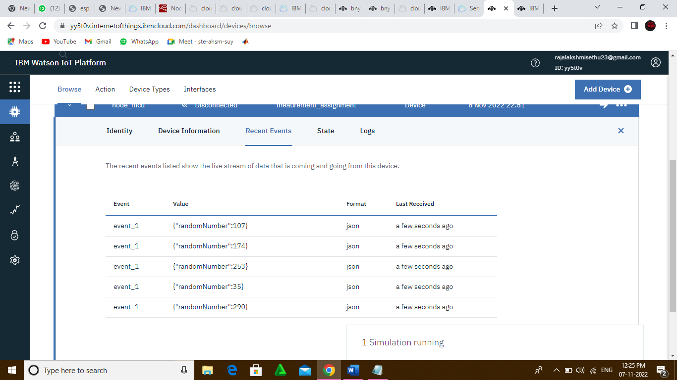

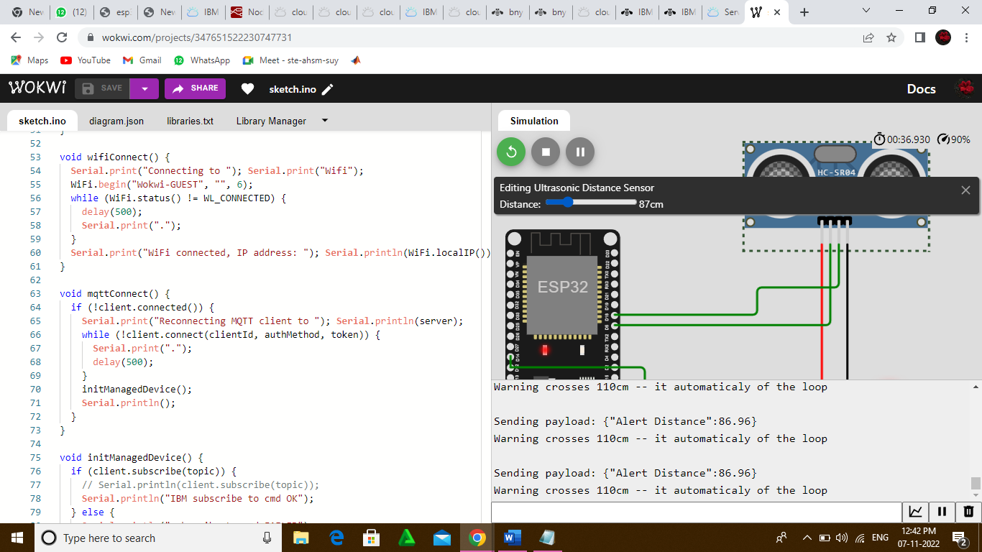

**Link**: <https://wokwi.com/projects/347651522230747731>